**CPSC 304 Project Cover Page**

Milestone #: ___2_____

Date: ____27 Jul 2023____

Group Number: __14____

| **Name** | **Student Number** | **CS Alias (Userid)** | **Preferred E-mail Address** |
| --- | --- | --- | --- |
| Iris Zhang | 29544764 | k8f3v | iriszhang50@gmail.com |
| Eleonora Diakonova | 95044343 | y5b3b | el.diak00@gmail.com |
| Erika Tian | 68414689 | m2w2b | scenery@student.ubc.ca |

By typing our names and student numbers in the above table, we certify that the work in the attached assignment was performed solely by those whose names and student IDs are included above. (In the case of Project Milestone 0, the main purpose of this page is for you to let us know your e-mail address, and then let us assign you to a TA for your project supervisor.)

In addition, we indicate that we are fully aware of the rules and consequences of plagiarism, as set forth by the Department of Computer Science and the University of British Columbia

2 & 3. ER Diagram and Schema

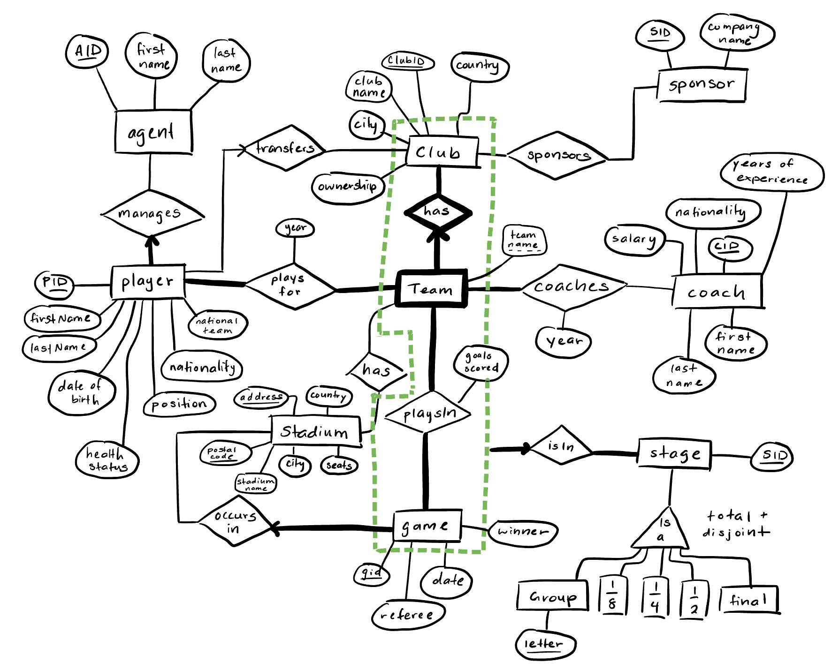

Changes to ER Diagram:

* Added the following attributes to create functional dependencies:
  + National team for player entity
  + Years of experience for coach entity
  + Postal code for stadium entity
* Removed the weak entity relationship between club and game because of feedback and created a new weak entity relationship between team and club
  + A team now belongs to a club
  + Player plays for a team but transfers clubs
  + A sponsor sponsors a club
  + A team has a stadium and a coach
  + Now team playsIn a game rather than a club

Agent (AID: CHAR(10), first_name: CHAR(20), last_name: CHAR(20))

Player (PID: CHAR(10), **AID**: CHAR(10), first_name: CHAR(20), last_name: CHAR(20), date_of_birth: int, health_status: CHAR(1), nationality: CHAR(3), national_team: CHAR(3), position: CHAR(20)) where AID is not NULL

PlayerPlaysForTeam (**PID**: CHAR(10), **clubID**: CHAR(10), **team_name:** CHAR(20), year: int)

Sponsor (SID: CHAR(10), company_name: CHAR(20))

Sponsors (**SID**: CHAR(10), **clubID**: CHAR(10))

Club (clubID: CHAR(10), club_name: CHAR(20), country: CHAR(20), city: CHAR(20), ownership: CHAR(20))

Team (team_name: CHAR(20), **clubID**: CHAR(10))

TeamHasStad (**team_name**: CHAR(20), **clubID**: CHAR(10), **address**: CHAR(20), **postal_code**: int)

Stadium (address: CHAR(20), postal_code: int, country: CHAR(20), city: CHAR(20), stadium_name: CHAR(20), number_of_seats: int)

TeamPlaysInGame (**clubID**: CHAR(10), **team_name**: CHAR(20), **GID**: CHAR(10), goals: int)

Game (GID: CHAR(10), **address**: CHAR(20), **postal_code**: int, date: int, referee: CHAR(20), winner: CHAR(10), goals_scored: int)

Coach (CID: CHAR(10), first_name: CHAR(20), last_name: CHAR(20), nationality: CHAR(3), salary: int, years_of_experience: int)

Coaches (**CID**: CHAR(10), **clubID**: CHAR(10), **team_name**: CHAR(20), year: int)

GameIsInStage (**clubID**: CHAR(10), **team_name**: CHAR(20), **GID**: CHAR(10), **SID**: CHAR(10))

SID is not NULL

Stage (SID: CHAR(10))

Group (**SID**: CHAR(10), letter: CHAR(1))

1/8 (**SID**: CHAR(10))

¼ (**SID**: CHAR(10))

½ (**SID**: CHAR(10))

Final (**SID**: CHAR(10))

* 1. 4 & 5. Functional Dependencies (FDs) AND Normalization
  2. (a). R = stadium(address, postal code, country, city, name, number of seats)
  3. Functional dependency (FDs):
  4. postal code –> city, country
  5. name –> city
  6. address, city, country –> postal code, name, number of seats
  7. **Find Closure AND check if the relation is in BCNF**:
  8. (1) postal code+ = {postal code, city, country}
  9. (2) name+ = {name, city}
  10. (3) address, city, country+ = {address, city, country, postal code, name, number of seats}

1. As (1) and (2) violate the definition of BCNF, this relation is **NOT** in BCNF.
   1. **Find minimal keys** **AND check if the relation is in 3NF**:

| Left | Middle | Right |
| --- | --- | --- |
| address | city, country, name, postal code | number of seats |

Check:

address + = {address}, as it’s not a key.

Then, add 1 element from the middle section and check:

address, city + = {address, city}

address, country + = {address, country}

address, name + = {address, name, city}

address, postal code + = {address, postal code, city, country, name, number of seats}

Hence, (**address, postal code**) is a key.

**List all explicit & implicit FDs**:

* 1. postal code –> city
  2. postal code –> country
  3. name –> city
  4. address, city, country –> postal code
  5. address, city, country –> name
  6. address, city, country –> number of seats
  7. **Decomposition**:
  8. Decompose R using *postal code –> city*

1. R1 = (postal code, city) **R1 is in BCNF**
2. R2 = (address, country, name, number of seats, postal code) **R2 is NOT in BCNF**
   1. Decompose R2 using *postal code –> country*
3. R3 = (postal code, country) **R3 is in BCNF**
4. R4 = (address, name, number of seats, postal code) **R4 is in BCNF**

Therefore, we get three relations:

R1 = (postal code, city), R3 = (postal code, country), R4 = (address, name, number of seats, postal code)

* 1. (b) R = Coach(CID, first name, last name, nationality, salary, years of experience)
     1. Functional dependency (FDs):
     2. CID -> first name, last name, nationality, salary, years of experience
     3. years of experience -> salary
     4. **Find Closure AND check if the relation is in BCNF**:
     5. years of experience+ = {years of experience, salary}

It violates the definition of BCNF, this relation is **NOT** in BCNF.

**CID** is the key.

* + 1. **Decomposition**:
    2. Decompose R on years of experience -> salary since it violates BCNF
  1. R1 = (years of experience,, salary) **R1 is in BCNF**
  2. R2 = (CID, first name, last name, nationality, years of experience) **R2 is in BCNF**

Therefore, we get two relations:

R1 = (years of experience,, salary), R2 = (CID, first name, last name, nationality, years of experience)

6 & 7. SQL DDL AND Populate at least 5 tuples

Agent instance:

* 1. 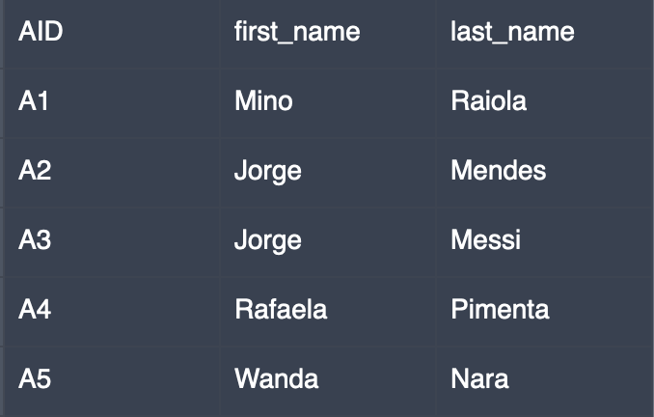

Player instance:

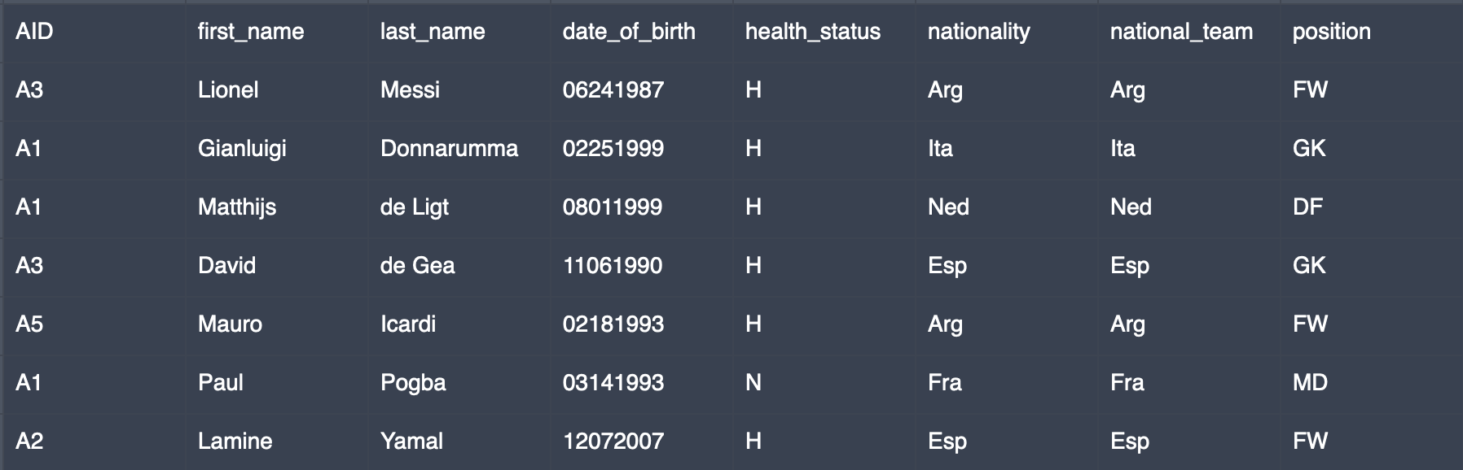

PlayerPlaysforTeam instance: Sponsor instance:

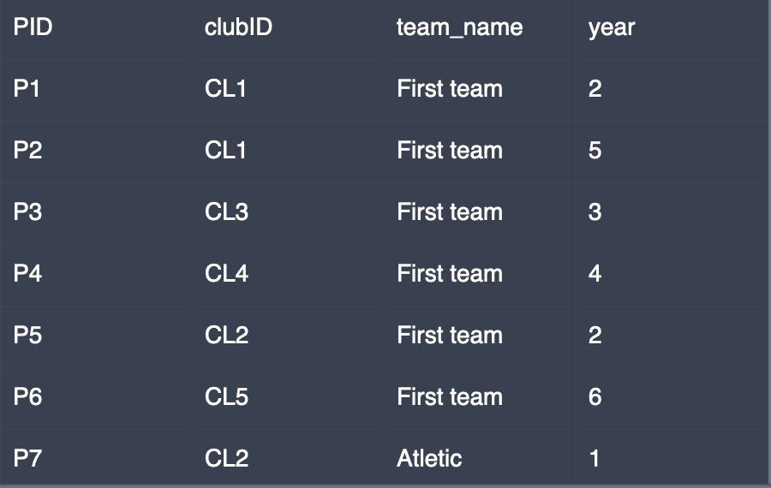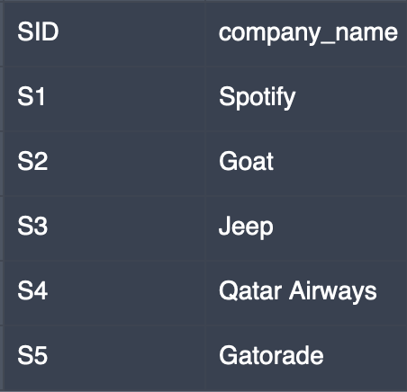

Sponsors instance:

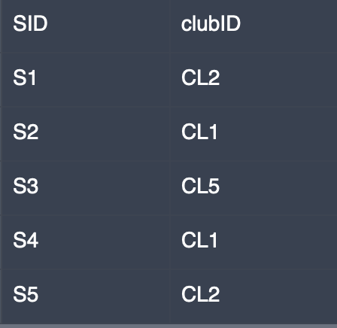

Club instance:

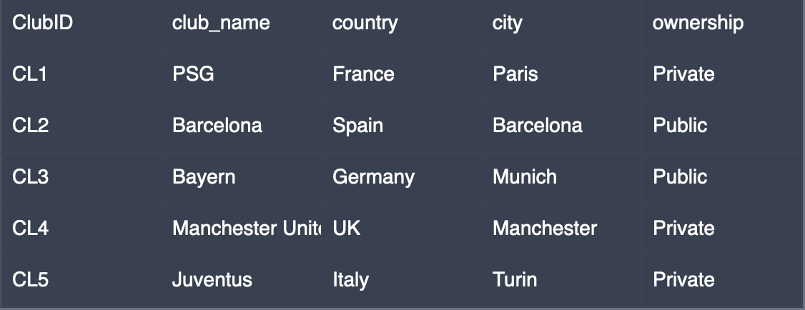

Team instance: Stadium_PCI instance: Stadium_PCO instance:

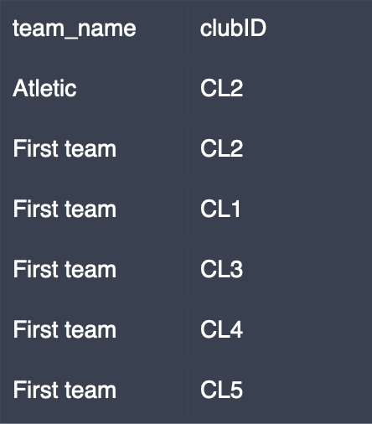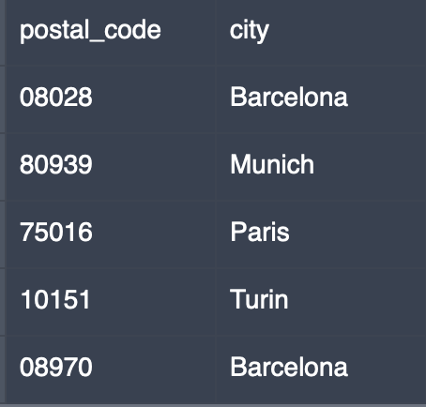 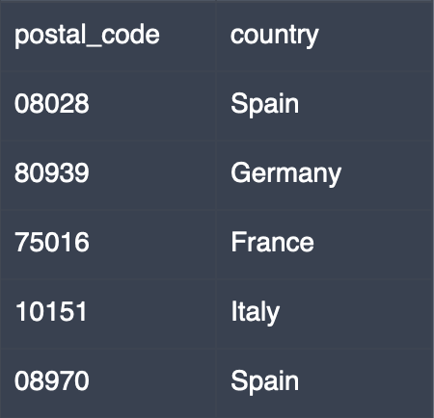

Stadium_PNAS instance:

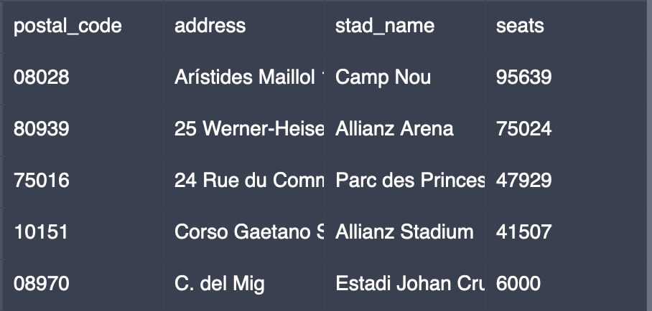

teamHasStad instance:

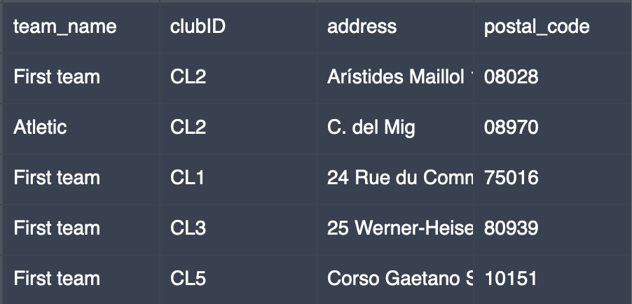

Game instance:

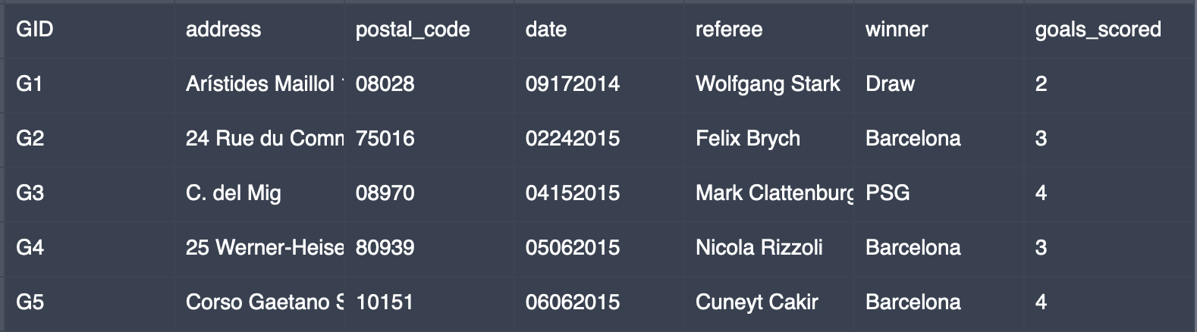

teamPlaysInGame instance:

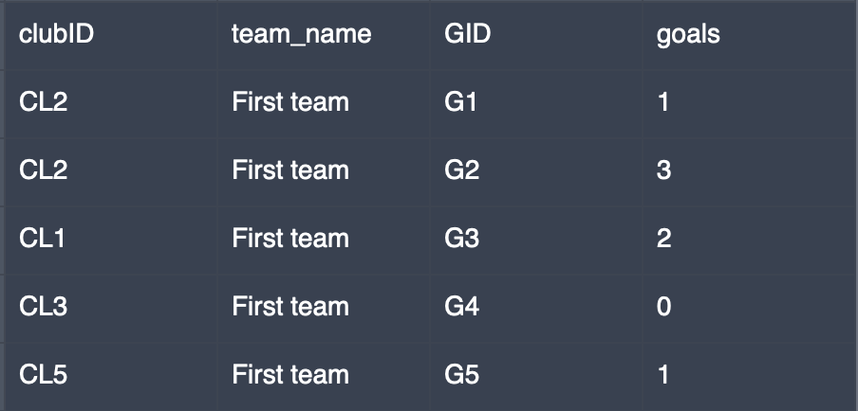

Coach_C1 instance:

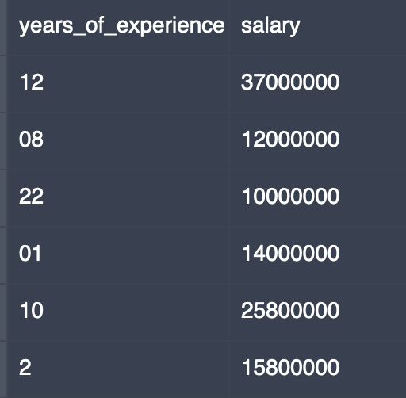

Coach_C2 instance:

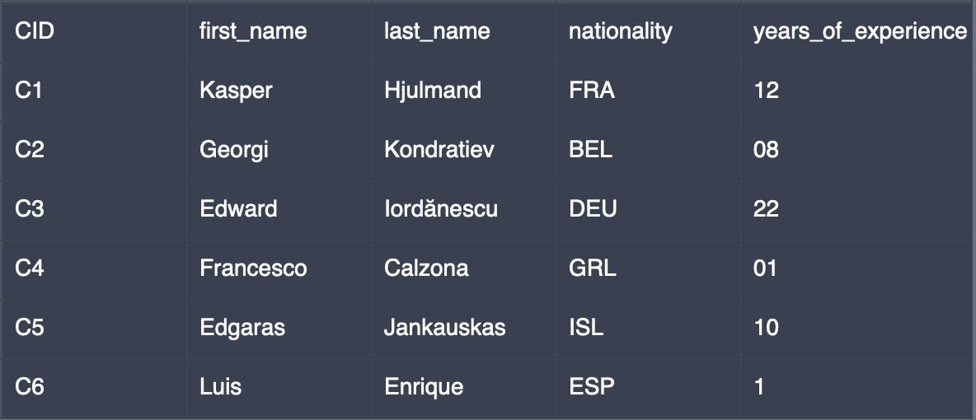

Coaches instance:

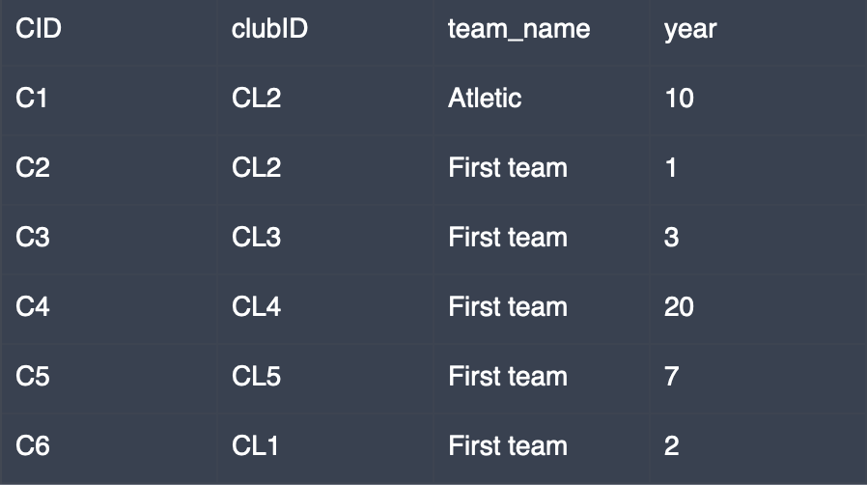

GameIsInStage instance:

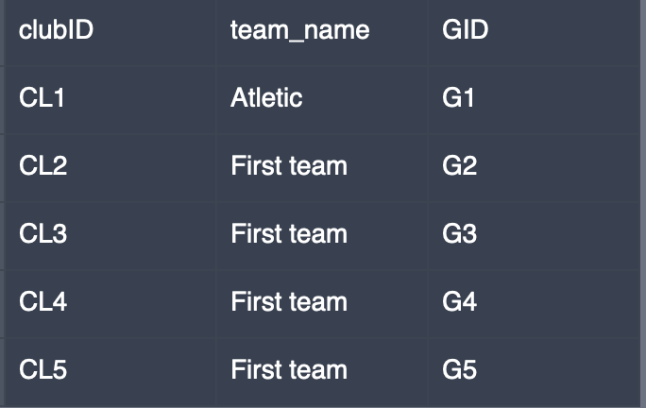

Group instance:

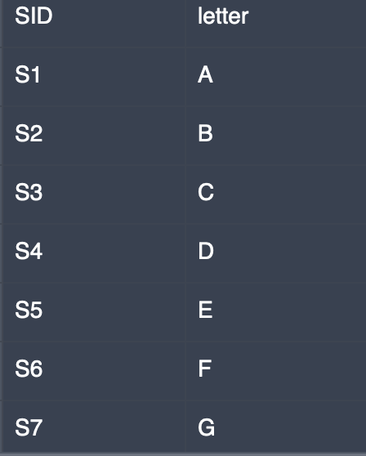

* 1. **SQL DDL (Tables):**

CREATE TABLE Agent (

AID char(10) PRIMARY KEY,

first_name char(20),

last_name char(20)

);

CREATE TABLE Player (

PID char(10) PRIMARY KEY,

AID char(10) NOT NULL,

first_name char(20),

last_name char(20),

date_of_birth int,

health_status char(1),

nationality char(3),

national_team char(3),

position char(20),

FOREIGN KEY (AID) REFERENCES Agent (AID)

);

CREATE TABLE PlayerPlaysForTeam (

PID char(10),

clubID char(10),

team_name char(20),

year int,

PRIMARY KEY (PID, clubID, team_name),

FOREIGN KEY (PID) REFERENCES Player (PID),

FOREIGN KEY (clubID, team_name) REFERENCES Team,

);

CREATE TABLE Sponsor (

SID char(10) PRIMARY KEY,

company_name char(20)

);

CREATE TABLE Sponsors (

SID char(10),

clubID char(10),

PRIMARY KEY (SID, clubID),

FOREIGN KEY (SID) REFERENCES Sponsor (SID),

FOREIGN KEY (clubID) REFERENCES Club (clubID)

);

CREATE TABLE Club (

clubID CHAR(10) PRIMARY KEY,

club_name CHAR(20),

country CHAR(20),

city CHAR(20),

ownership CHAR(20)

);

CREATE TABLE Team (

team_name CHAR(20),

clubID CHAR(10),

PRIMARY KEY(clubID, team_name),

FOREIGN KEY(clubID) REFERENCES Club,

ON DELETE CASCADE

);

/* Stadium was decomposed to BCNF */

CREATE TABLE Stadium_PCI (

postal_code INTEGER PRIMARY KEY,

city CHAR(20),

);

CREATE TABLE Stadium_PCO (

postal_code INTEGER PRIMARY KEY,

country CHAR(20),

);

CREATE TABLE Stadium_PNAS (

postal_code INTEGER,

address CHAR(20),

stad_name CHAR(20),

seats INTEGER,

PRIMARY KEY(address, postal_code)

);

CREATE TABLE teamHasStad (

team_name CHAR(20),

clubID CHAR(10),

address CHAR(20),

postal_code INTEGER

PRIMARY KEY(team_name, clubID, address, postal_code)

FOREIGN KEY(team_name, clubID) REFERENCES Team,

FOREIGN KEY(address, postal_code) REFERENCES Stadium_PNAS

);

CREATE TABLE Game (

GID CHAR(10) PRIMARY KEY,

address CHAR(20) NOT NULL,

postal_code INTEGER NOT NULL,

date INTEGER,

referee CHAR(20),

winner CHAR(10),

goals_scored INTEGER,

FOREIGN KEY(address, postal_code) REFERENCES Stadium_PNAS

ON DELETE NO ACTION

ON UPDATE CASCADE

);

CREATE TABLE teamPlaysInGame (

clubID CHAR(10),

team_name CHAR(20),

GID CHAR(10),

goals INTEGER,

PRIMARY KEY(clubID, team_name, GID),

FOREIGN KEY(clubID, team_name) REFERENCES Team,

FOREIGN KEY(GID) REFERENCES Game

);

/* Coach was decomposed to BCNF */

CREATE TABLE Coach_C1 (

years_of_experience INT PRIMARY KEY,

salary INT

);

CREATE TABLE Coach_C2 (

CID CHAR(10) PRIMARY KEY,

first_name CHAR(20),

last_name CHAR(20),

nationality CHAR(3),

years_of_experience INT

);

CREATE TABLE Coaches (

CID CHAR(10) NOT NULL,

clubID CHAR(10),

team_name CHAR(20),

year INT,

PRIMARY KEY(CID, clubID, team_name),

FOREIGN KEY(CID) REFERENCES Coach

FOREIGN KEY(clubID, team_name) REFERENCES Team

);

CREATE TABLE GameIsInStage (

clubID CHAR(10),

team_name CHAR(20),

GID CHAR(10),

PRIMARY KEY(clubID, team_name, GID),

FOREIGN KEY(clubID, team_name) REFERENCES Team,

FOREIGN KEY(GID) REFERENCES Game

);

CREATE TABLE Group (

SID CHAR(10),

letter CHAR(1);

PRIMARY KEY(SID, letter)

);

CREATE TABLE S1_8 (

SID CHAR(10) PRIMARY KEY

);

CREATE TABLE S1_4 (

SID CHAR(10) PRIMARY KEY

);

CREATE TABLE S1_2 (

SID CHAR(10) PRIMARY KEY

);

CREATE TABLE final (

SID CHAR(10) PRIMARY KEY

);

* 1. /* Populate tuples: */

INSERT INTO Agent VALUES ("A1", "Mino", "Raiola");

INSERT INTO Agent VALUES ("A2", "Jorge", "Mendes");

INSERT INTO Agent VALUES ("A3", "Jorge", "Messi");

INSERT INTO Agent VALUES ("A4", "Rafaela", "Pimenta");

INSERT INTO Agent VALUES ("A5", "Wanda", "Nara");

INSERT INTO Player VALUES ("P1", "A3", "Lionel", "Messi", 06241987, "H", "Arg", "Arg", "FW");

INSERT INTO Player VALUES ("P2", "A1", "Gianluigi", "Donnarumma", 02251999, "H", "Ita", "Ita", "GK");

INSERT INTO Player VALUES ("P3", "A1", "Matthijs", "de Ligt", 08011999, "H", "Ned", "Ned", "DF");

INSERT INTO Player VALUES ("P4", "A3", "David", "de Gea", 11061990, "H", "Esp", "Esp", "GK");

INSERT INTO Player VALUES ("P5", "A5", "Mauro", "Icardi", 02181993, "H", "Arg", "Arg", "FW");

INSERT INTO Player VALUES ("P6", "A1", "Paul", "Pogba", 03141993, "N", "Fra", "Fra", "MD");

INSERT INTO Player VALUES ("P7", "A2", "Lamine", "Yamal", 12072007, "H", "Esp", "Esp", "FW");

INSERT INTO PlayerPlaysForTeam VALUES ("P1", "CL1", "First team", 2);

INSERT INTO PlayerPlaysForTeam VALUES ("P2", "CL1", "First team", 5);

INSERT INTO PlayerPlaysForTeam VALUES ("P3", "CL3", "First team", 3);

INSERT INTO PlayerPlaysForTeam VALUES ("P4", "CL4", "First team", 4);

INSERT INTO PlayerPlaysForTeam VALUES ("P5", "CL2", "First team", 2);

INSERT INTO PlayerPlaysForTeam VALUES ("P6", "CL5", "First team", 6);

INSERT INTO PlayerPlaysForTeam VALUES ("P7", "CL2", "Atletic", 1);

INSERT INTO Sponsor VALUES ("S1", "Spotify");

INSERT INTO Sponsor VALUES ("S2", "Goat");

INSERT INTO Sponsor VALUES ("S3", "Jeep");

INSERT INTO Sponsor VALUES ("S4", "Qatar Airways");

INSERT INTO Sponsor VALUES ("S5", "Gatorade");

INSERT INTO Sponsors VALUES ("S1", "CL2");

INSERT INTO Sponsors VALUES ("S2", "CL1");

INSERT INTO Sponsors VALUES ("S3", "CL5");

INSERT INTO Sponsors VALUES ("S4", "CL1");

INSERT INTO Sponsors VALUES ("S5", "CL2");

INSERT INTO Club VALUES ("CL1", "PSG", "France", "Paris", "Private");

INSERT INTO Club VALUES ("CL2", "Barcelona", "Spain", "Barcelona", "Public");

INSERT INTO Club VALUES ("CL3", "Bayern", "Germany", "Munich", "Public");

INSERT INTO Club VALUES ("CL4", "Manchester United", "UK", "Manchester", "Private");

INSERT INTO Club VALUES ("CL5", "Juventus", "Italy", "Turin", "Private");

INSERT INTO Team VALUES ("Atletic", "CL2");

INSERT INTO Team VALUES ("First team", "CL2");

INSERT INTO Team VALUES ("First team", "CL1");

INSERT INTO Team VALUES ("First team", "CL3");

INSERT INTO Team VALUES ("First team", "CL4");

INSERT INTO Team VALUES ("First team", "CL5");

INSERT INTO Stadium_PCI VALUES (08028, "Barcelona");

INSERT INTO Stadium_PCI VALUES (80939, "Munich");

INSERT INTO Stadium_PCI VALUES (75016, "Paris");

INSERT INTO Stadium_PCI VALUES (10151, "Turin");

INSERT INTO Stadium_PCI VALUES (08970, "Barcelona");

INSERT INTO Stadium_PCO VALUES (08028, "Spain");

INSERT INTO Stadium_PCO VALUES (80939, "Germany");

INSERT INTO Stadium_PCO VALUES (75016, "France");

INSERT INTO Stadium_PCO VALUES (10151, "Italy");

INSERT INTO Stadium_PCO VALUES (08970, "Spain");

INSERT INTO Stadium_PNAS VALUES (08028, "Arístides Maillol 12", "Camp Nou", 95639);

INSERT INTO Stadium_PNAS VALUES (80939, "25 Werner-Heisenberg-Allee", "Allianz Arena", 75024);

INSERT INTO Stadium_PNAS VALUES (75016, "24 Rue du Commandant Guilbaud", "Parc des Princes", 47929);

INSERT INTO Stadium_PNAS VALUES (10151, "Corso Gaetano Scirea 50", "Allianz Stadium", 41507);

INSERT INTO Stadium_PNAS VALUES (08970, "C. del Mig", "Estadi Johan Cruyff", 6000);

INSERT INTO teamHasStad VALUES ("First team", "CL2", "Arístides Maillol 12", 08028);

INSERT INTO teamHasStad VALUES ("Atletic", "CL2", "C. del Mig", 08970);

INSERT INTO teamHasStad VALUES ("First team", "CL1", "24 Rue du Commandant Guilbaud", 75016);

INSERT INTO teamHasStad VALUES ("First team", "CL3", "25 Werner-Heisenberg-Allee", 80939);

INSERT INTO teamHasStad VALUES ("First team", "CL5", "Corso Gaetano Scirea 50", 10151);

INSERT INTO Game VALUES ("G1", "Arístides Maillol 12", 08028, 09172014, "Wolfgang Stark", "Draw", 2);

INSERT INTO Game VALUES ("G2", "24 Rue du Commandant Guilbaud", 75016, 02242015, "Felix Brych", "Barcelona", 3);

INSERT INTO Game VALUES ("G3", "C. del Mig", 08970, 04152015, "Mark Clattenburg", "PSG", 4);

INSERT INTO Game VALUES ("G4", "25 Werner-Heisenberg-Allee", 80939, 05062015, "Nicola Rizzoli", "Barcelona", 3);

INSERT INTO Game VALUES ("G5", "Corso Gaetano Scirea 50", 10151, 06062015, "Cuneyt Cakir", "Barcelona", 4);

INSERT INTO teamPlaysInGame VALUES ("CL2", "First team", "G1", 1);

INSERT INTO teamPlaysInGame VALUES ("CL2", "First team", "G2", 3);

INSERT INTO teamPlaysInGame VALUES ("CL1", "First team", "G3", 2);

INSERT INTO teamPlaysInGame VALUES ("CL3", "First team", "G4", 0);

INSERT INTO teamPlaysInGame VALUES ("CL5", "First team", "G5", 1);

INSERT INTO Coach_C1 VALUES (12, 37000000);

INSERT INTO Coach_C1 VALUES (08, 12000000);

INSERT INTO Coach_C1 VALUES (22, 10000000);

INSERT INTO Coach_C1 VALUES (01, 14000000);

INSERT INTO Coach_C1 VALUES (10, 25800000);

INSERT INTO Coach_C1 VALUES (2, 15800000);

INSERT INTO Coach_C2 VALUES ("C1", "Kasper", "Hjulmand", "FRA", 12);

INSERT INTO Coach_C2 VALUES ("C2", "Georgi", "Kondratiev", "BEL", 08);

INSERT INTO Coach_C2 VALUES ("C3", "Edward", "Iordănescu", "DEU", 22);

INSERT INTO Coach_C2 VALUES ("C4", "Francesco", "Calzona", "GRL", 01);

INSERT INTO Coach_C2 VALUES ("C5", "Edgaras", "Jankauskas", "ISL", 10);

INSERT INTO Coach_C2 VALUES ("C6", "Luis", "Enrique", "ESP", 1);

INSERT INTO Coaches VALUES ("C1", "CL2", "Atletic", 10);

INSERT INTO Coaches VALUES ("C2", "CL2", "First team", 1);

INSERT INTO Coaches VALUES ("C3", "CL3", "First team", 3);

INSERT INTO Coaches VALUES ("C4", "CL4", "First team", 20);

INSERT INTO Coaches VALUES ("C5", "CL5", "First team", 7);

INSERT INTO Coaches VALUES ("C6", "CL1", "First team", 2);

INSERT INTO GameIsInStage VALUES ("CL1", "Atletic", "G1");

INSERT INTO GameIsInStage VALUES ("CL2", "First team", "G2");

INSERT INTO GameIsInStage VALUES ("CL3", "First team", "G3");

INSERT INTO GameIsInStage VALUES ("CL4", "First team", "G4");

INSERT INTO GameIsInStage VALUES ("CL5", "First team", "G5”);

INSERT INTO Group VALUES ("S1", "A");

INSERT INTO Group VALUES ("S2", "B");

INSERT INTO Group VALUES ("S3", "C");

INSERT INTO Group VALUES ("S4", "D");

INSERT INTO Group VALUES ("S5", "E");

INSERT INTO Group VALUES ("S6", "F");

INSERT INTO Group VALUES ("S7", "G");

INSERT INTO Group VALUES ("S8", "H");

/* stages after groups shouldn’t have more than 1 tuple */

* 1. INSERT INTO S1_8 VALUES ("S9");

1. INSERT INTO S1_4 VALUES ("S10");

INSERT INTO S1_2 VALUES ("S11");

1. INSERT INTO final VALUES ("S12");